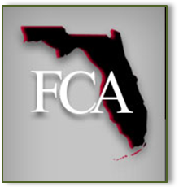
Since 1930 coordinating the efforts of teachers, students and others interested in the communication arts and sciences in Florida
FLORIDA COMMUNICATION ASSOCIATION NEWSLETTER
An Award-Winning Organization
January 2007
A Message from Your
FCA President
Rich Mercadante
FCA President

Greetings fellow FCA members! I hope that this newsletter finds all of you doing well.

It was good to see so many of you in St. Petersburg for our 76th annual convention. Plans are already underway for our next convention: October 11-13, 2007 at the Shores Resort and Spa in Daytona Beach.

On January 20th, our FCA executive board met at the convention hotel. Located directly on the beach, this is an outstanding facility. I hope that you will begin making plans to join us in October.

Following our board meeting, we held a workshop with our web developer, Mark Omran of Kairosix, Inc. Look for major improvements to our FCA website in the very near future. We are making convention paper submissions and registration more user-friendly.
Call for Papers
Kim K. Johnson
First Vice-President
Globalization & Communication
People * Power * Politics
What is the good, the bad and the ugly about Globalization as seen through the lens of Communication, on People – Power – Politics?
Our goal is to explore the relationship between globalization and communication in all its manifestations. From mass communication to economics, international teaching exchange programs to grass roots political change, communication innovation is playing a significant role in the rapid expansion of “globalization”. This year’s theme provides the opportunity to research all aspects of our new ‘flat’ world.
The deadline for submission of proposals is
May 15, 2007
* Competitive Papers: (3) Categories - Professional, Undergraduate, and Graduate
Submit a 100 word abstract by May 15. Final papers will be due by June 30. Please indicate “competitive paper” and category on the abstract.
*Poster Sessions: (2) Categories -Undergraduate and Graduate
Submit a 100 word abstract on the nature of the poster by May 15. The Poster Session will be held on Saturday, October 13. Please indicate the category on the abstract.
*Panels, Workshops, and Individual Papers
Submit a 100 word abstract by May 15. For panels, include the names and affiliations of all panel participants, including your name if you are on the panel. For workshops, develop the rationale for the workshop in addition to the abstract. Individual papers will be combined into programs around the convention theme.
You may submit your proposals through the website at www.flcom.org.
If you have suggestions or would like to help with convention planning, please contact (kkjohnson@adelphia.net) with your ideas and indicate where you’d like to assist. Here are some ways you might help:
- Program submission review and selection
- Session moderators
- Thursday evening spotlight program
- Convention reception
- Sponsorship for a number of convention related activities including breaks, lunches, printing, keynote speaker, entertainment, etc.
This is a great opportunity to highlight your program and institution! 

I would like to challenge each of you to consider how you might become a proactive member of FCA. Perhaps you might consider participating in FCA in one or more of the
following ways:
- Our FCA Journal offers an opportunity to submit research and professional development articles.

- Our annual convention provides numerous ways to participate as a chair or presenter in one of our sessions. Please consider submitting a paper or volunteering to chair a session.

- FCA awards are offered for faculty (Outstanding Service, Teacher of the Year, Scholar of the Year) and for students (FCA Student Scholarship, Top Undergraduate Paper, Top Graduate Paper). Why not consider nominating a fellow FCA member for a faculty award or encouraging a student to apply for the scholarship or one of the paper awards? The FCA Grant funds worthy communication projects in Florida. Perhaps you might consider applying for this $500 grant.

You will find information about many of these opportunities in this newsletter. Please feel free to contact me if you need some guidance.

“I challenge each of you to consider how you might become a proactive member of FCA.”

I welcome your ideas and input. Let us join together to make 2007 an exceptional year for FCA!

Inside This Issue
1 | President’s Message
2 | Call for Papers
2 | 2006 Convention 1st Vice President’s Comments
3 | In Memoriam – Wallace V. Schmidt
4 | FCA Awards
5 | FCA Receives State Showcase Award of Excellence
6 | FCA Convention – A Student’s Perspective
6 | A Note from FCA’s Second Vice President

continued on page 3

2006 Convention
1st Vice-President’s Comments
Carol Bledsoe
1st Vice-President, 2006

Thank you to everyone who made our 2006 convention a big success! Our attendance was strong and our theme “Models of Excellence” was well supported with a rich variety of programs. Our special guests, Steve Brydon and Mike Scott, added a special dimension to the weekend and have expressed their appreciation for FCA’s warm welcome and hospitality. It was wonderful to renew friendships with former FCA colleagues – and to meet/welcome those attending for the first time. Our student participation was encouraging as we look to these rising scholars who will be contributing to our discipline for years to come. I want to personally thank the FCA board and those of you who helped in the convention planning in many capacities. Whether you were involved with convention planning, presented or moderated a program, or honored us with your attendance during the weekend, you have my personal gratitude. I encourage everyone to support Kim Johnson as she plans the 2007 convention – and I look forward to seeing you in Daytona Beach Shores next October! 

.

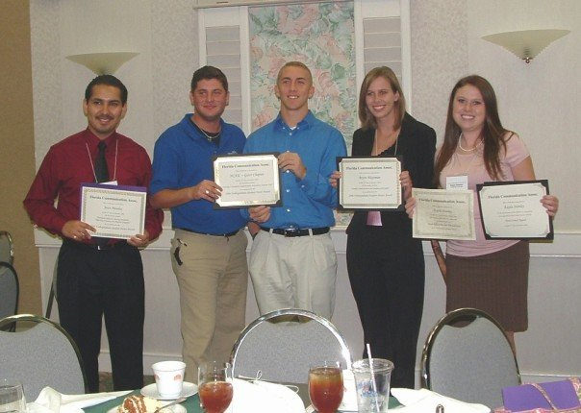
University of Florida Students receive awards at the FCA Annual Convention
In Memoriam
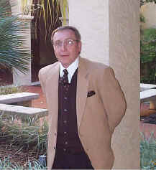
Wallace V. Schmidt, PhD
Sue Easton

It is with deep sadness that we report the death of Wallace V. Schmidt on Sunday, February 25, 2007. At the time of his death, Wally was a Professor of Organizational Communication at Rollins College in Winter Park Florida. Previously, he has taught at Hofstra University, Texas Tech University, and The University of Texas at Tyler.
Wallace Schmidt was a past president of the Florida Communication Association and was currently serving on the Executive Board as the journal editor. He was an active member of the National Communication Association, Association for Business Communication, and American Society for Training and Development.
He has presented professional papers at international, national, regional, and state conferences and conducted business workshops in the areas of intercultural diversity, conflict management and crisis planning, and creative problem solving. He was also the author of several books, including one recently released by Sage Publications, Communicating Globally: Intercultural Communication and International Business.
Dr. Schmidt received a B.A. degree, cum laude from Midland Lutheran College in speech and communication, the M.A. in communication from the University of Nebraska, and a Ph.D. in organizational communication from New York University. In 2004, the Florida Communication Association presented him with their Outstanding Scholarship Award. He received the Walter E. Barden Award for Excellence and Innovation in Teaching from Rollins College in 1992 and again in 2005.
He is survived by his wife Susan and their son and daughter-in-law, Matthew and Stephanie Schmidt.
Wally was a great scholar, good husband, father, friend and a gentle mentor. He will be missed.
Personal Information
Mrs. Susan Schmidt
120 N. Pressview
Longwood, FL 32750

In lieu of flowers the family requests donations be made to the Hamilton Holt School Student Scholarship Fund:
Rollins College Hamilton Holt School
1000 Holt Ave – 2723
Winter Park, FL 32789-4499

FCA Board of Directors

Richard Mercandante, President
Mercandante.richard@spcollege.edu
Deb Hefferin, Immediate Past President
dhefferi@broward.edu
Kim K. Johnson, 1st VP, Convention Chair 2007
kkjohnson@adelphia.net
Chrissy Gesmundo, 2nd VP, Membership
discodiva1974@yahoo.com
Jim Katt, Treasurer
jkatt@mail.ucf.edu
Sue Easton, Recording Secretary
seaston@rollins.edu
Wally Schmidt, FCJ Editor
wschmidt@rollins.edu
Diana Nagy, Education Liaison
dnagy@ufl.edu
Richard Quianthy, NCA Rep
rquianth@broward.edu
MJ Wagner, Newsletter Director
mjwagner@mail.ucf.edu
Shari Hodgson, Web Editor
sharvin@aol.com
FCA Awards
Deborah Hefferin
Immediate Past President

Last year, Carol Bledsoe challenged everyone to raise the bar by examining how we teach/research/serve the profession. It was an exciting convention and I think everyone was impressed with the quality and expertise that we see among our members. There is a spirit of excellence that is infused in FCA.

In the spirit of that meeting we should recognize the excellence that we enjoy. FCA has a long history of celebrating members who have or are doing an exemplary job. We should be awarding and honoring all of our members who are doing "special stuff." Some of these people are oldies, but, goodies. Others are newbies to the research field. How do we best say, “We’re proud of you!”

We should be awarding and honoring all of our members who are doing "special stuff."
Well, it’s time for you to make a nomination for one or all of the FCA Awards. Each year we seek to recognize outstanding work from those in our discipline. Our three main awards are for
- Teaching: this award is given to someone (at any level of teaching speech communication) that has demonstrated outstanding ability in the classroom.
- Scholarship: this award is given to someone who has shown outstanding scholarly achievements.
- Service: this award is given to someone who has promoted the mission and goals of FCA and contributed to the Association over several years.

Please consider nominating someone for any or all of these positions. Self nominations are encouraged. A brief letter of nomination explaining the qualifications of the nominee should be sent to

Deborah Hefferin
Communication Dept.
Broward Community College
1000 Coconut Creek Blvd.
Pompano Beach, FL 33066
dhefferi@broward.edu

The deadline for nominations is May 15. Please submit today. The Awards Committee, Christa Arnold, Berrin Beasley, and Bonnie Jefferis. will be considering the nominations, seeking further support from the nominees, and after making the selections, presenting the awards when we meet in Daytona in October. 

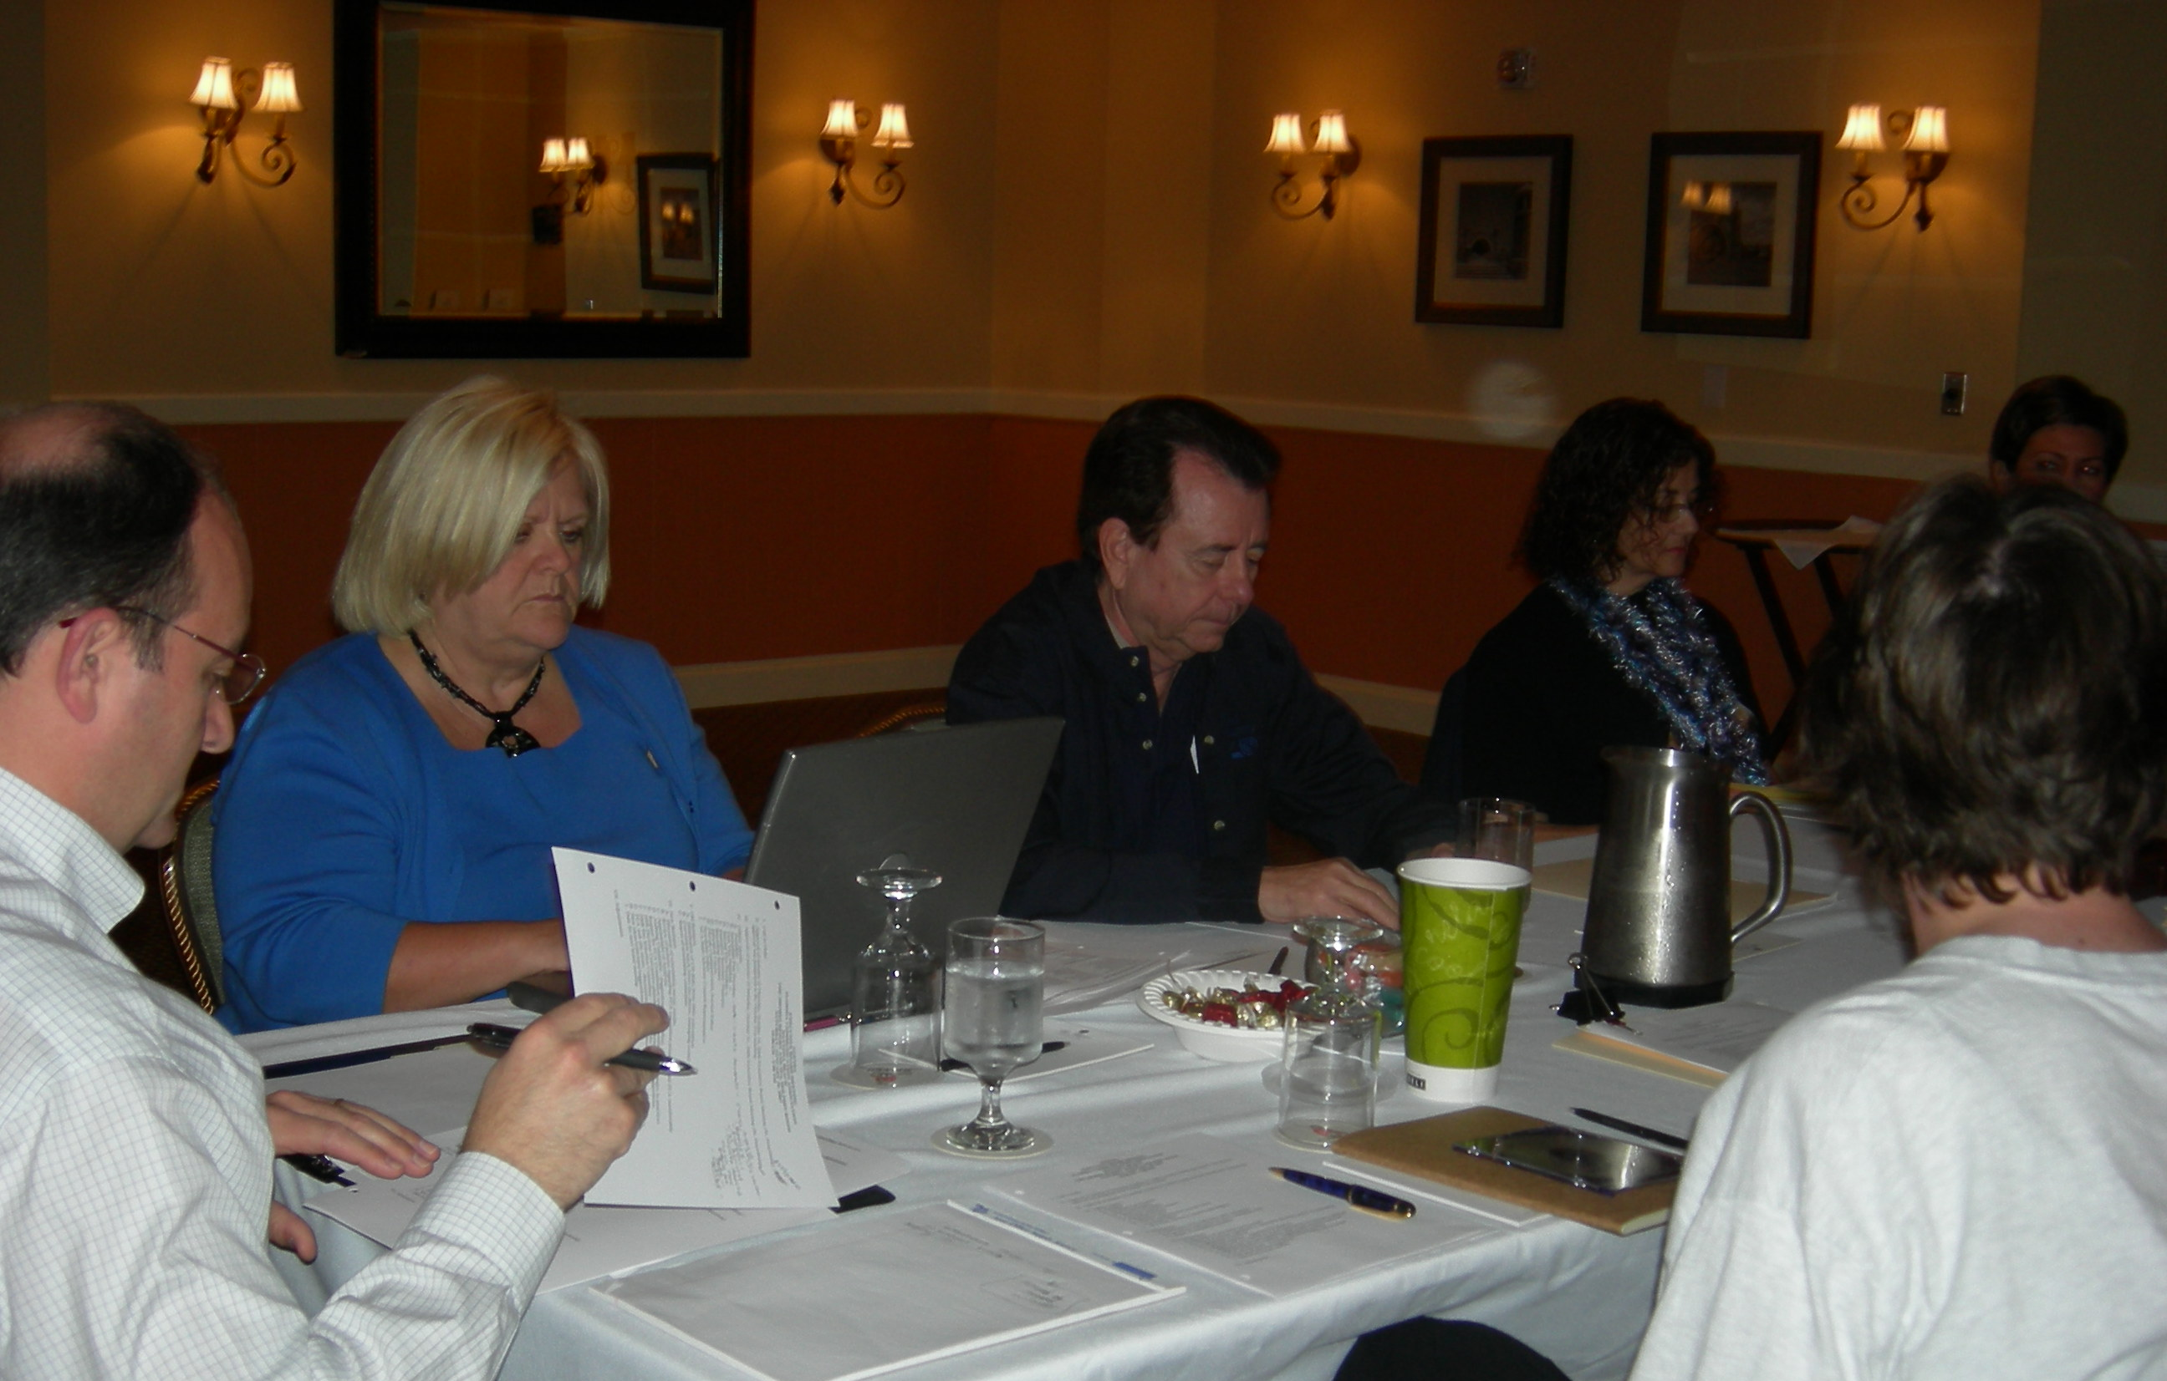

January 20, 2007 Board of Directors Meeting
Daytona Beach Shores

FCA Receives State Showcase Award of Excellence at the National Communication Association Conference in San Antonio

Richard Quianthy
NCA Representative

Robert Littlefield, Chair of the States Advisory Council, presented the award to Richard Quianthy, FCA’s SAC representative at the business meeting of the SAC in San Antonio. The Award Certificate reads: States Advisory Council State Showcase Award of Excellence, presented to Kim Johnson, Deborah Hefferin, Richard Quianthy, James Katt, and Susan Easton for participation in the panel showcasing the Florida Communication Association at the National Communication Association Convention in San Antonio, Texas. November 18, 2006.

The panelists discussed the operation and various functions of the FCA. Discussion included the role and functions of the Immediate Past President, President, First Vice-President, Second Vice President, Treasurer, Recording Secretary, Newsletter Editor, Journal Editor and the NCA SAC representative and Archivist.

Following a lively discussion, the audience members congratulated the panel on the accomplishments of the FCA. 

FCA 2006 Conference Memories

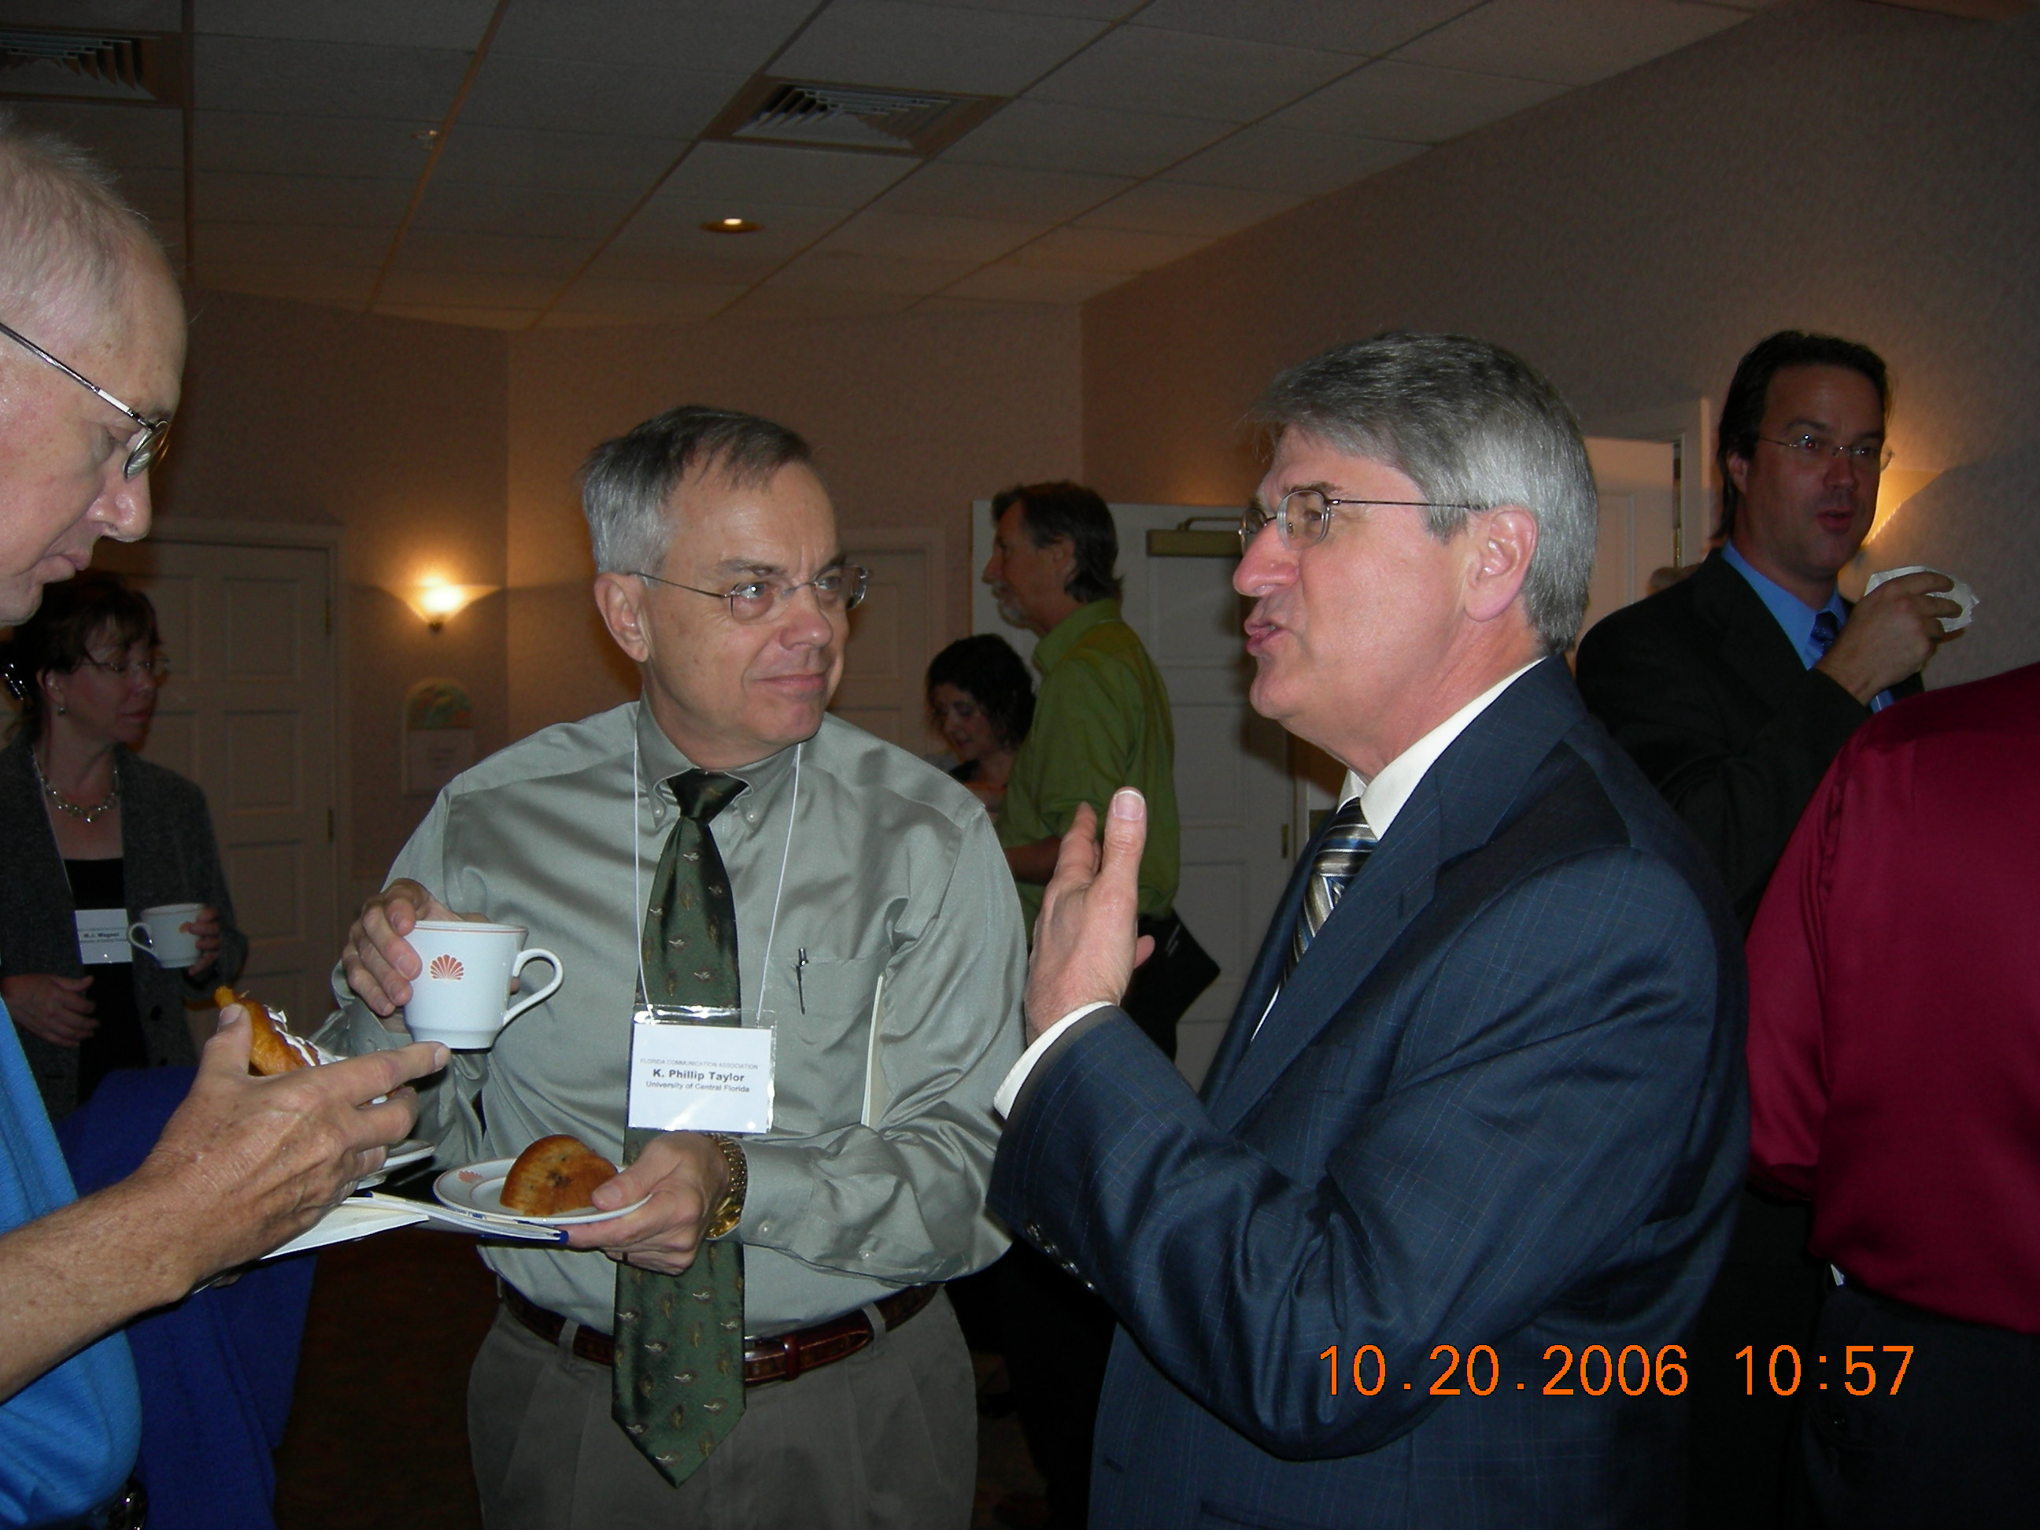
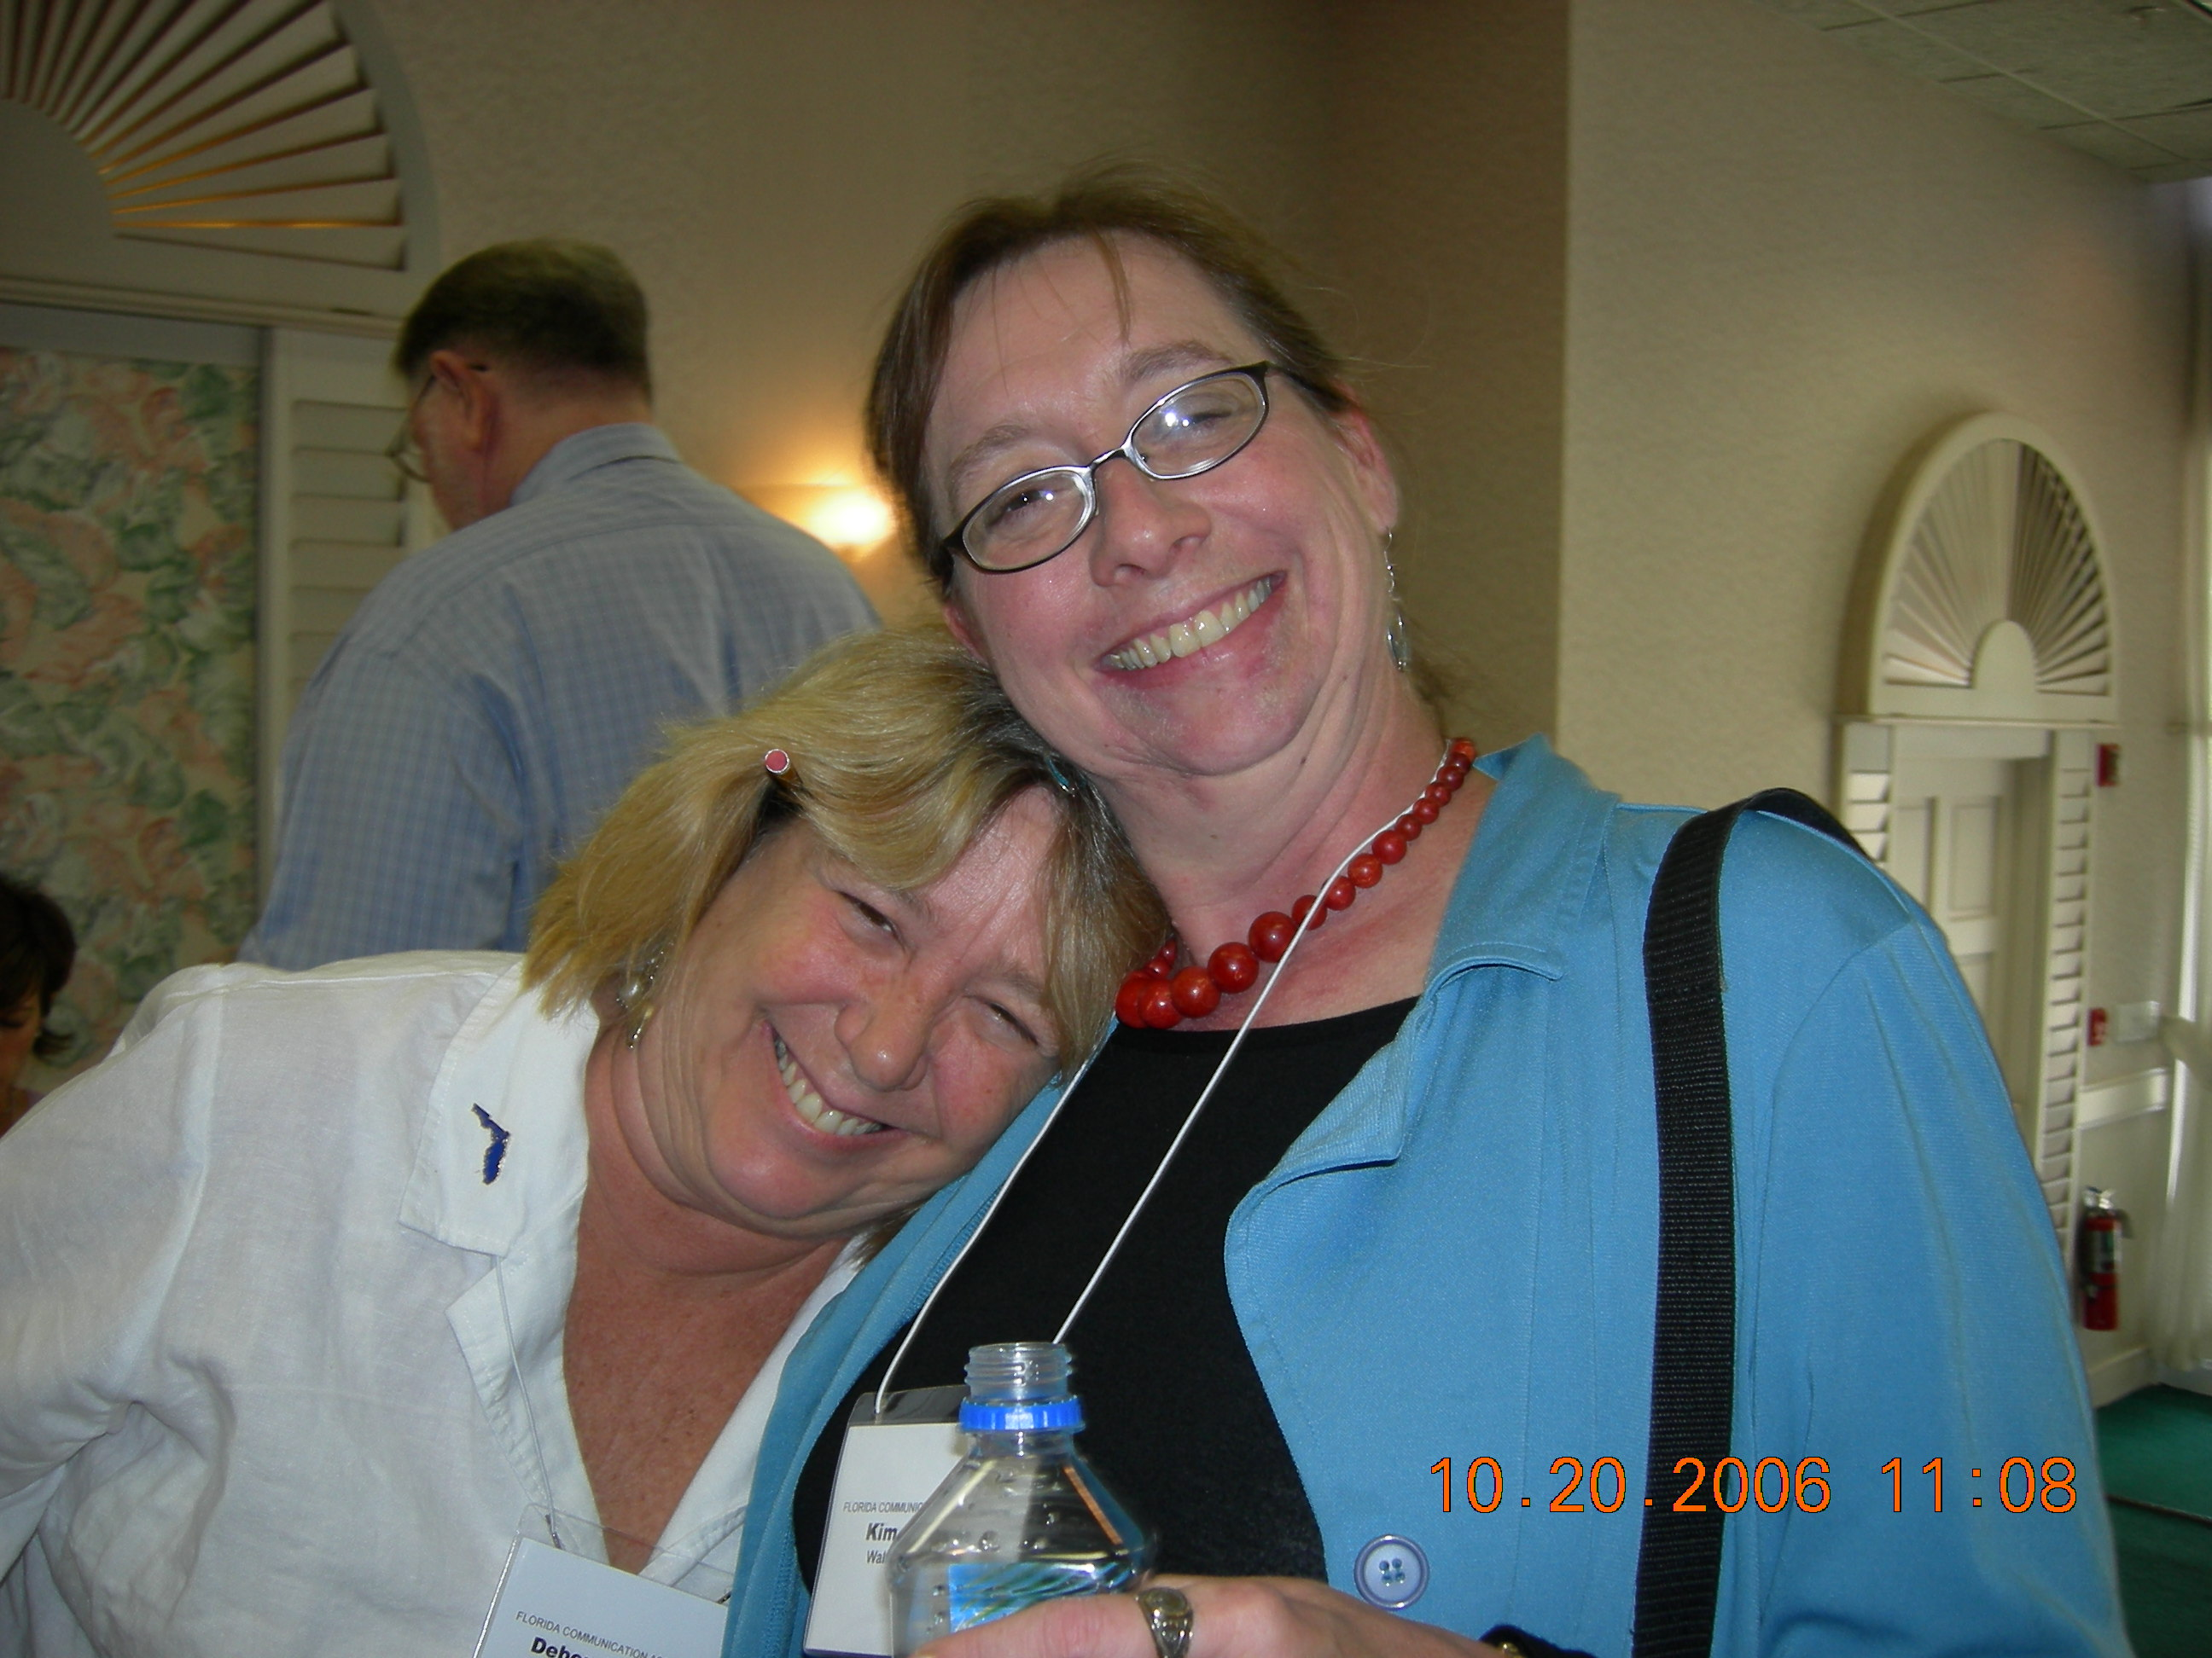
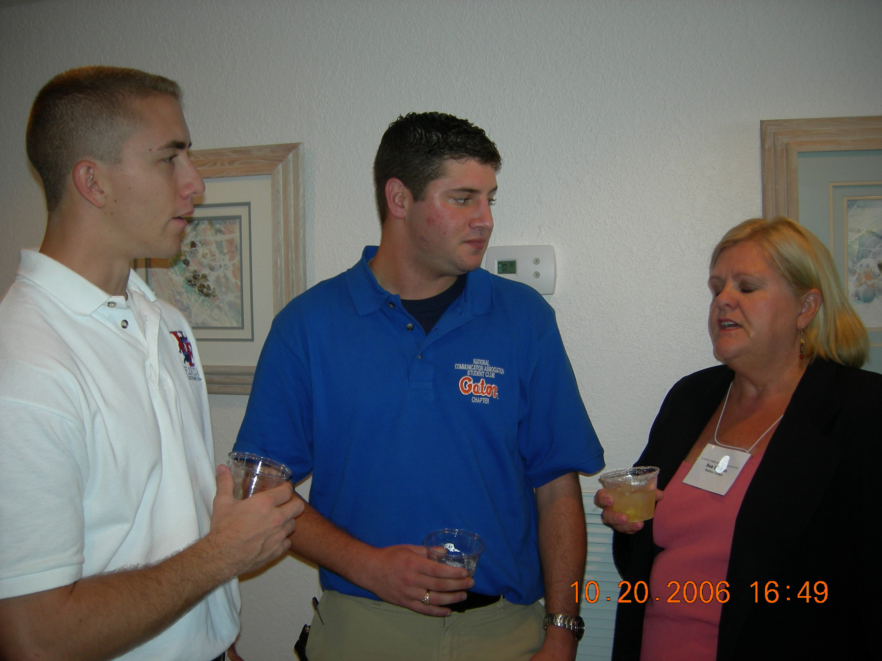
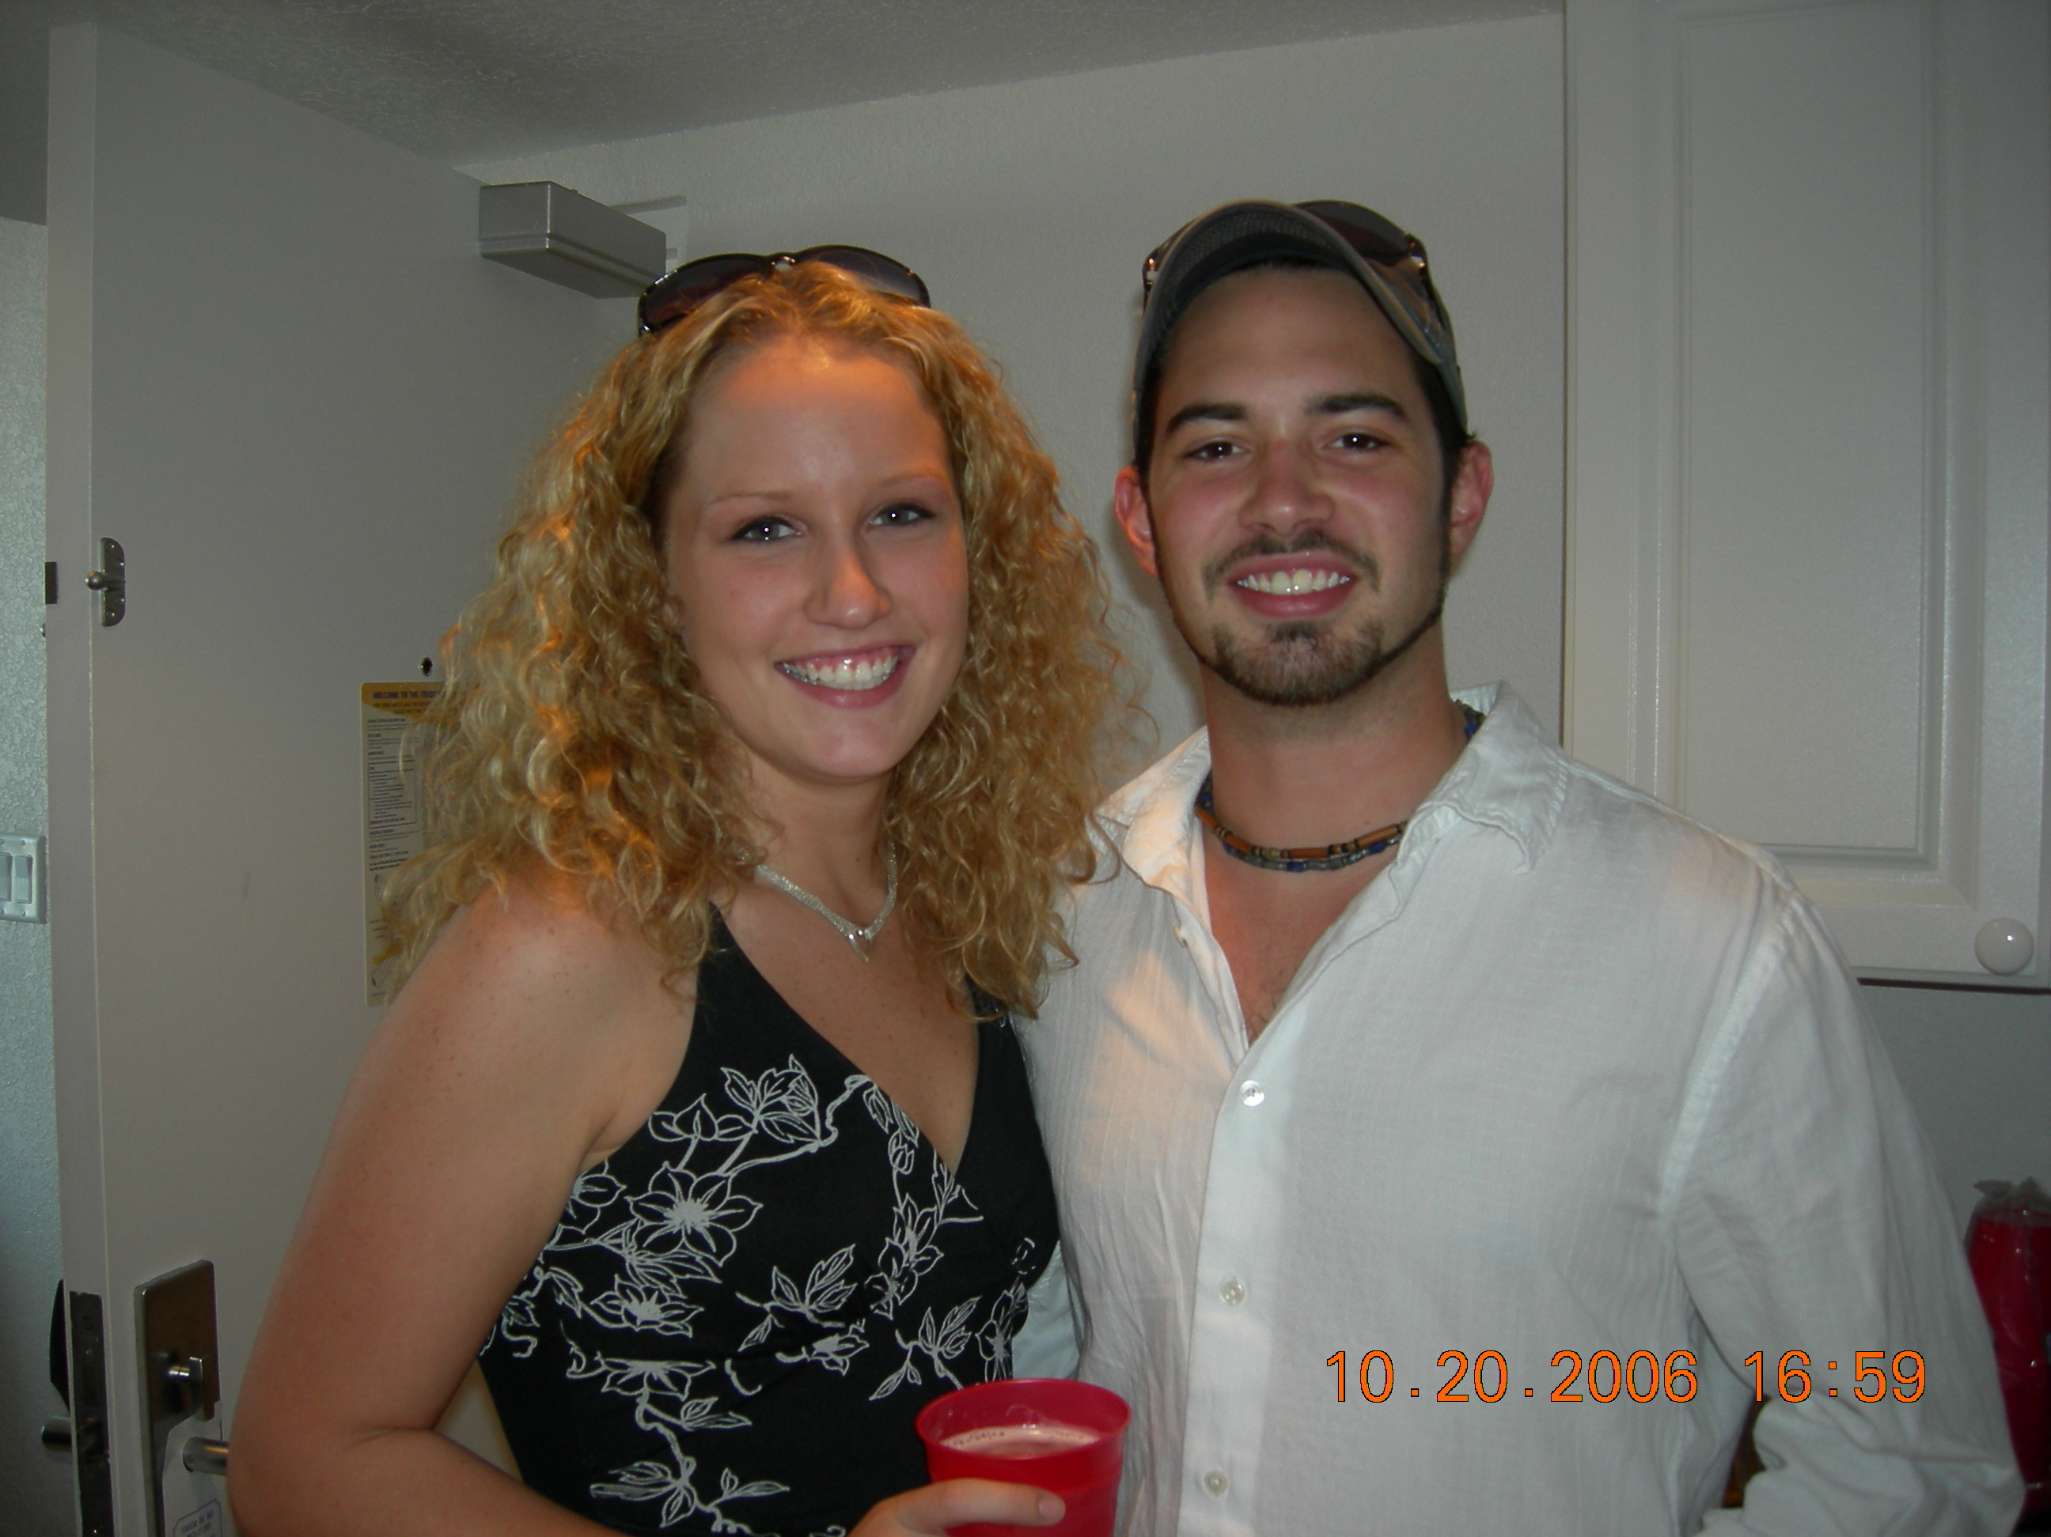
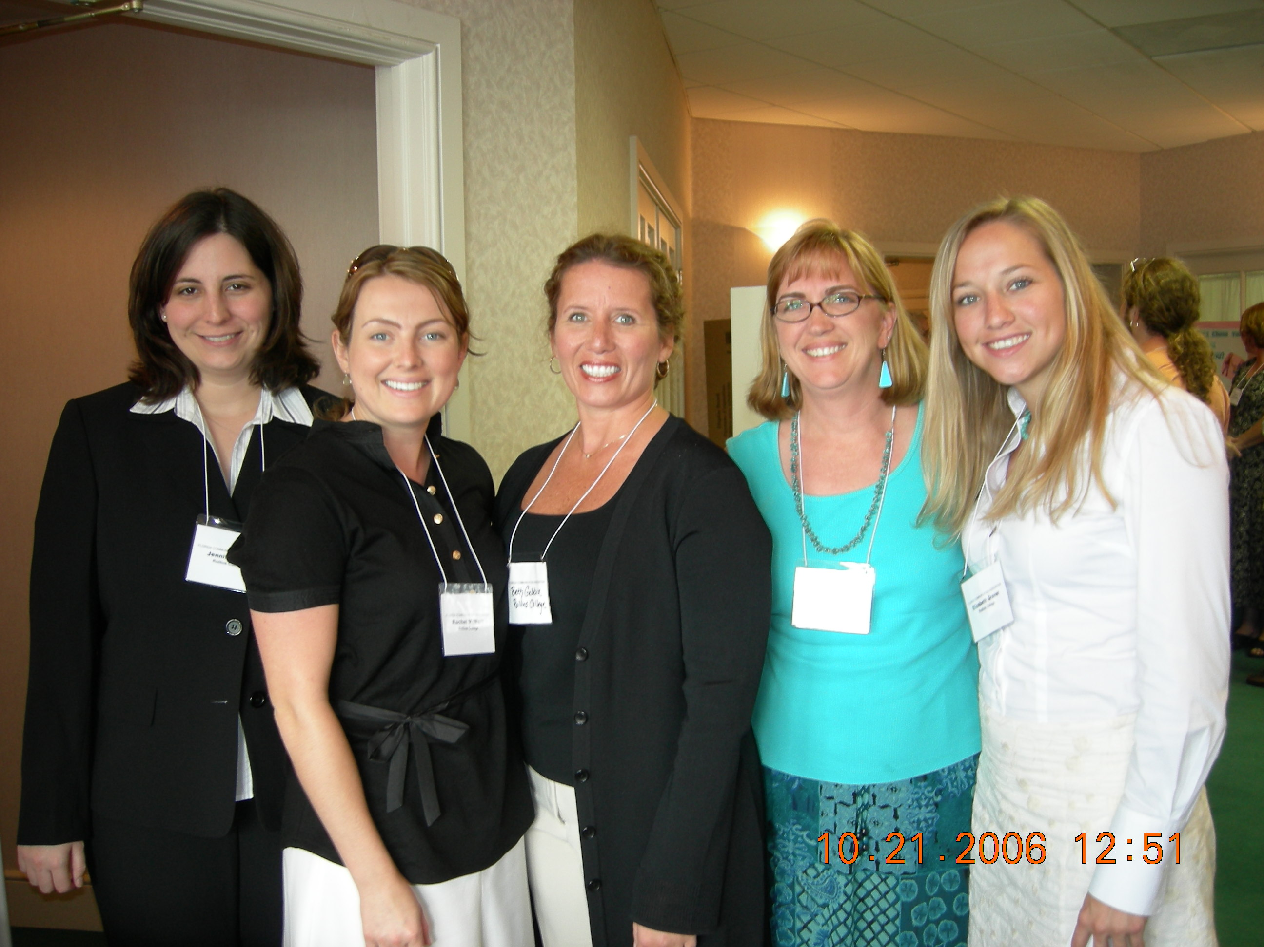

2006 FCA Convention - A Student’s Perspective
Jim Careccia
University of Florida

St. Pete Beach provided the perfect backdrop to host this past year’s FCA Conferences. The entire event was filled with useful information, great contacts, and plenty of fun. After reflecting on the weekend with my friends and advisor who also went, we all agreed it was one of the best weekends we had in college.

The five of us walked away from the conference with hilarious inside jokes, a deeper passion for communication and a stronger bond that students crave in college. Our passion for communication shined brightly at a networking meeting attended by my group from the University of Florida, Coastal Carolina University and Rollins College. We exchanged ideas on how to better our communication organizations, socialized, and set-up a contact list to share ideas and get together in the future.

My personal goal for attending the conference was to make important contacts for my own future, and the future of our communication organization. Diana Nagy, our advisor,

introduced me to Kim Johnson, who deals with communications and public relations at Disney. Kim and I had a great chat about internships at Disney and what public relations professionals do. She is heading down to UF in March to speak to our communication organization, and I feel her talk will better enlighten all that attend.

In addition to knowledge and networking, there’s always room for socializing and having a good time. The group in my hotel room stayed up most of the night laughing and talking about whatever came to mind. After looking back on how tired we were the next day, it struck me. We may have been up all night, but were we not communicating? This is what the conference was about. The weekend brought us together, allowed us to get close, and now we all feel like buddies, Diana Nagy included. We look forward in helping to plan next year’s conference. However, this time we may have to get to bed before 3 a.m.! 

A Note from FCA’s Second Vice President
Christina Gesmundo

Touch base with FCA! Contact us (info@flcom.org) to verify your information. In order to get you all of the benefits of FCA membership, we need your correct email address as well as your mailing address.

One of my goals as 2nd VP is to encourage an active membership. Whether you are just starting out in your Communication career, working towards Tenure, or getting ready to retire, there is something for everyone!
- Consider mentoring a junior faculty member
- Discuss FCA memberships and benefits at your monthly faculty meetings
- Submit your research or paper proposals to our annual convention

Also, if you have names and suggestions for individuals who would like to become members or Campus Contacts, send them in! I’ll do all the work of setting them up. We especially would like to see active Campus Contacts at the following schools:
- St Leo College
- Bethune Cookman
- Flagler College
- Florida International

Many of you have expressed interest in greater involvement with FCA. Contact me (discodiva1974@yahoo.com) if you would like to participate in any of the following activities:
- Committee screening---this includes convention site selection!
- Membership—getting Communication professionals involved
- Awards Committee---selecting recipients for the multiple financial and honorary awards FCA bestows
- Campus Contact—announcing and posting flyers about FCA, its benefits, convention, and membership

I know I can rely on the loyal members of FCA! Therefore, I hope to hear from you!

